Breast Cancer Stage Classification with miRNA

A Report Submitted by
Group 44
Joshua Adegboyo: jadegboyo2023@fau.edu
Anika Baro Villa: abarovilla2021@fau.edu
Nicholas Campos: ncampos2022@fau.edu
Brehon Parker: bparker2012@fau.edu

December 7, 2025

Sponsor/Project Advisor
Dr. Ali Ibrahim: aibrahim2014@fau.edu

FAU Department of Electrical Engineering and Computer Science

SUMMARY
Author: Nicholas Campos
This report presents a systematic pipeline for breast cancer stage classification using microRNA (miRNA) expression data from The Cancer Genome Atlas (TCGA). Current breast cancer staging methods rely on invasive biopsies and expensive imaging procedures. MicroRNAs offer potential as non-invasive biomarkers, but the challenge lies in identifying which of the 1,881 available miRNA features are truly meaningful for distinguishing cancer stages from limited patient samples.
Our proposed solution addresses this high-dimensionality problem through a multi-method comparison approach. We systematically evaluated three feature selection families, including traditional machine learning, deep learning, and clustering methods, across four stage-wise classification tasks (Normal versus Stages I through IV). Each family provided different perspectives on feature importance, which we combined through consensus analysis to identify robust biomarker candidates. The selected miRNA panels were then evaluated using multiple classifiers with appropriate validation strategies adapted to each stage's sample size constraints.
The implemented system successfully processed 1,209 patient samples, generated stage-specific miRNA panels through twelve different feature selection methods, and achieved an average classification accuracy of 67.9% across all stages. The modular pipeline design ensures reproducibility, allows fair comparison across methods, and produces interpretable results suitable for biological validation. Testing results demonstrate that our systematic approach meets the core project specifications: reliable feature selection under high-dimensionality constraints, transparent methodology enabling result interpretation, and appropriate handling of class imbalance through stage-adapted validation strategies.

TABLE OF CONTENTS
SUMMARY 2
LIST OF FIGURES 4
LIST OF TABLES 5
I. INTRODUCTION 6
A. Background 6
B. Statement of the Problem 6
C. Literature Review 7
II. SCOPE OF WORK 8
A. Overview 8
B. Alternative Solutions 9
C. Evaluation 10
D. Decision 11
III. IMPLEMENTATION DETAILS 12
A. System Specifications and Functionalities 13
B. Overall System Design using System Diagram(s) with Discussions 14
C. Detailed Subsystem Design using UML and Circuit Diagrams with Explanations 16
C.1 Data Preprocessing and Stage-Wise Dataset Subsystem 16
C.2 Stage-wise Feature Selection Subsystem 17
C.3 Stage-wise Consensus miRNA Panel Subsystem 18
C.4 Classification and Evaluation Subsystem 20
C.5 Explainability and Literature Validation Subsystem 21
D. Comprehensive Testing Results with Discussions 22
IV. CONCLUDING REMARKS 25
V. REFERENCES 27

LIST OF FIGURES

Figure 1: UML activity diagram of the stage-wise breast cancer miRNA classification pipeline. 14
Figure 2: UML activity diagram of the data preprocessing and stage-wise dataset subsystem. 16
Figure 3: UML activity diagram of the stage-wise feature selection subsystem. 17
Figure 4: UML activity diagram of the stage-wise consensus miRNA panel subsystem. 19
Figure 5: UML activity diagram of the classification and evaluation subsystem. 20
Figure 6: UML activity diagram of the explainability and literature validation subsystem. 21
Figure 7: Stage-wise Classification Accuracy 23
Figure 8: Stage-wise Sensitivity and Specificity 23

LIST OF TABLES

Table 1: Decision Matrix for Alternative miRNA Stage Classification Architectures. 11
Table 2: Overall dataset distribution for TCGA breast cancer miRNA samples. 12
Table 3: Stage-wise binary dataset sizes and validation strategies. 21

I. INTRODUCTION

Author: Joshua Adegboyo
This project focuses on designing a comprehensive, stage-wise computational pipeline for breast cancer classification using microRNA (miRNA) expression data. By integrating traditional machine-learning methods, deep learning models, and clustering techniques, the goal is to identify reliable biomarkers that differentiate normal breast tissue from cancer stages I through IV. The project emphasizes reproducibility, consistency across pipeline components, and comparative evaluation of multiple feature-selection approaches to determine the miRNAs most strongly associated with cancer progression.

A. Background
Author: Joshua Adegboyo
Breast cancer continues to be one of the most common and impactful cancers worldwide. Early detection and accurate staging are critical because treatment decisions and survival outcomes depend heavily on the stage at diagnosis. Traditional staging methods rely on imaging, clinical examination, and pathology, which can vary in accuracy and often struggle to detect early molecular changes.
MicroRNAs (miRNAs) have become an important research focus because they regulate gene expression and show measurable differences across cancer stages. Large public datasets, such as The Cancer Genome Atlas (TCGA), now provide thousands of miRNA expression features per patient. While this creates an opportunity for more precise computational analysis, it also introduces a major challenge: identifying which miRNAs are truly meaningful for distinguishing cancer stages.

B. Statement of the Problem
Author: Joshua Adegboyo
The primary issue addressed in this project is the difficulty of analyzing extremely high-dimensional miRNA data in a way that is reliable, interpretable, and clinically meaningful. With nearly 1,900 features and only around 1,200 patient samples, machine-learning models can easily overfit, and different feature-selection methods often produce inconsistent results.
There is currently no standardized pipeline that evaluates multiple feature-selection strategies side-by-side, filters out noise, and identifies which miRNAs consistently emerge as important across different computational methods and stages of breast cancer.
Without this, researchers lack a clear direction on which biomarkers warrant further biological investigation or clinical validation.
This project aims to solve this problem by building a stage-wise miRNA feature-selection pipeline that is consistent, transparent, and capable of identifying the most robust biomarkers for breast cancer staging.

C. Literature Review
Author: Joshua Adegboyo
Prior research strongly supports the role of miRNAs in cancer diagnostics and staging. Work by Iorio et al. (2005) demonstrated that deregulated miRNA expression patterns distinguish breast cancer tissue from normal samples and correlate with molecular subtypes. Similarly, Volinia et al. (2006) identified cancer-related miRNA signatures across multiple tumor types, highlighting their diagnostic potential.
Traditional feature-selection methods such as LASSO regression (Tibshirani, 1996), chi-square filtering, and sequential forward selection have been widely used to reduce dimensionality in genomic datasets. These methods remain popular for their simplicity and interpretability but often capture only linear associations.
Deep learning approaches have gained momentum due to their ability to model nonlinear relationships. Autoencoders, CNNs, and LSTM-based architectures have shown strong performance in genomic biomarker discovery (Alakwaa et al., 2018; Min et al., 2017). However, deep models frequently produce different feature rankings compared to traditional methods, raising concerns about stability and reproducibility.
Unsupervised clustering methods—such as K-means, spectral clustering, and hierarchical clustering—have been used to group miRNAs based on co-expression patterns, which can reveal functional relationships (Jiang et al., 2018). Yet, these approaches also vary in their outputs depending on initialization parameters and cluster-selection rules.
Across these studies, a consistent theme emerges: no single algorithm provides definitive biomarker rankings. This reinforces the need for a multi-method, stage-wise consensus approach like the one developed in this project.

II. SCOPE OF WORK

A. Overview
Author: Brehon Parker
This project aims to design an accurate, robust, and interpretable system for stage wise breast cancer classification using microRNA (miRNA) expression data from The Cancer Genome Atlas (TCGA). The core objective is to determine which feature selection strategies most reliably identify meaningful miRNA biomarkers under conditions typical of real biological datasets, including high dimensionality, class imbalance, and limited sample size.
The work was organized into four phases, each aligned with the system architecture presented in the implementation section.
- Dataset Construction and Preparation
TCGA miRNA Seq data and clinical metadata were curated into a unified dataset in which each patient record contains normalized miRNA values and a corresponding encoded cancer stage. The dataset was then restructured into four independent stage wise classification tasks: Normal vs Stage I, Normal vs Stage II, Normal vs Stage III, and Normal vs Stage IV.
- Stage Wise Feature Selection
For each stage, feature selection was performed using three independent method families: traditional statistical approaches, deep learning models, and clustering based techniques. This allowed direct comparison of selection behavior using the same data.
- Consensus Panel Generation and Classification
Outputs from each feature selection family were consolidated into consensus miRNA panels to stabilize results and reduce method specific variability. These panels were evaluated through multiple classifiers to assess performance consistency.
- Explainability and Validation
Final feature sets were examined through frequency analysis and literature review. Recurring miRNAs were highlighted as potential biomarker candidates.
The deliverables include validated stage specific miRNA panels, classifier performance summaries, system diagrams, and biologically supported candidate biomarkers.

B. Alternative Solutions
Author: Brehon Parker
Several system design approaches were considered before selecting the final architecture.
Alternative 1: Single Feature Selection Method
One feature selection method such as LASSO or Chi Square is used prior to classifier training.
Strengths
- Simple workflow
- Efficient runtime
- Easy interpretation
Weaknesses
- High sensitivity to noise
- Limited generalization
- Strong dependence on one method
Alternative 2: Deep Learning Only System
Neural networks perform both feature scoring and classification.
Strengths
- Models nonlinear behavior
- Learns complex relationships
Weaknesses
- Requires large training datasets
- Lower interpretability
- High computational cost
Alternative 3: Clustering Only Biomarker Discovery
miRNAs are grouped using unsupervised learning methods.
Strengths
- Discovers expression structure
- No labels required
Weaknesses
- Weak classification accuracy
- Poor biological interpretability
- Cluster membership does not guarantee relevance
Final Strategy: Multi Family Consensus Framework
The selected system integrates traditional methods, deep learning, and clustering. Agreement between methods is used to filter instability and highlight consistent biomarkers.

C. Evaluation
Author: Brehon Parker
Design alternatives were evaluated using several technical and practical criteria. These included classification accuracy to ensure reliable stage prediction, interpretability so that selected features could be examined for biological meaning, robustness to handle noise and imbalance in the data, and scalability to support high dimensional input with thousands of miRNA features. Reproducibility was also a critical factor, requiring stable results across repeated experiments and consistent data splits, while computational cost was considered to ensure the system could operate within practical runtime and memory limits. Clinical relevance was emphasized to prioritize designs that support biomarker discovery and future validation rather than only predictive performance.
Several real world constraints also influenced the evaluation process. The dataset contains severe class imbalance, most notably for Stage IV where only a small number of cancer samples are available. This required careful consideration of validation strategies to avoid misleading performance estimates. Runtime and memory limits in the cloud execution environment restricted the size and complexity of models that could be used. Reproducibility requirements further constrained the design by enforcing strict data isolation and consistency across training runs. Ethical responsibility was also considered, with particular attention to avoiding diagnostic claims and ensuring that results were presented as exploratory research findings rather than clinical conclusions.

Note: Scores are assigned on a scale of 1 (poor) to 5 (excellent) based on observed performance during implementation and testing.
Criterion | Weight | Single Method | Deep Learning | Clustering | Multi-Family Consensus
Accuracy | 0.25 | 2 | 3 | 2 | 4
Interpretability | 0.15 | 3 | 2 | 2 | 4
Robustness | 0.15 | 2 | 3 | 2 | 5
Scalability | 0.1 | 4 | 3 | 3 | 4
Reproducibility | 0.1 | 5 | 3 | 4 | 5
Efficiency | 0.1 | 5 | 2 | 4 | 3
Clinical Relevance | 0.15 | 2 | 2 | 2 | 5
Weighted Score |  | 2.95 | 2.6 | 2.5 | 4.3

Table 1: Decision matrix for alternative miRNA stage classification architectures.

D. Decision
Author: Brehon Parker
The multi family consensus approach was selected as the final design because it provided the most consistent performance across stages. Traditional feature selection methods produced the most reliable accuracy under high dimensionality and limited sample size. Deep learning methods did not outperform traditional approaches and required greater computational cost. Clustering alone did not provide sufficient classification accuracy but contributed supporting structure when integrated.
Ethical responsibility was maintained by avoiding diagnostic claims and clearly stating research limitations, especially those related to small sample size in Stage IV and low sensitivity for Stage III.
The design we chose allows for future extension to larger datasets, independent validation cohorts, and additional disease types. It also supports expanded biomarker analysis by enabling new feature selection methods to be integrated into the existing pipeline and evaluated under the same framework.

III. IMPLEMENTATION DETAILS

A. System Specifications and Functionalities
Author: Anika Baro Villa
Our project implements a reproducible pipeline for breast cancer stage classification using microRNA (miRNA) expression data. The system is built around miRNA-Seq data from the breast cancer cohort of The Cancer Genome Atlas (TCGA), accessed through the National Cancer Institute's Genomic Data Commons (GDC) data portal. In this cohort, each patient sample includes a high-dimensional miRNA expression profile together with clinical information, including the pathologic breast cancer stage.
Our system implementation combines MATLAB and Python/Jupyter components. First, MATLAB scripts developed by our sponsor, Dr. Ali Ibrahim, as part of his previous research process the raw GDC downloads (miRNA quantification files for tumor and normal tissue, together with the corresponding clinical JSON metadata) and convert them into a single CSV file named breast_cancer.csv, which serves as the main input to our Python-based analysis pipeline. This dataset contains 1,209 patient samples with 1,881 miRNA expression features, plus one label column that encodes the breast cancer stage. Each row corresponds to one patient sample, each feature column stores a normalized miRNA expression value, and the final column uses 0 for normal tissue samples and 1 through 4 for Stages I through IV.
When we look at the distribution of samples across stages in the breast_cancer.csv dataset, we see that they are not evenly balanced. Stage II has the largest number of cancer cases (595 samples), Stage I and Stage III have moderate numbers (173 and 161 samples, respectively), and Stage IV has very few cases (15 samples). The dataset also includes 265 normal tissue samples. Later in the pipeline, we pair these normal samples with each cancer stage to create four separate binary datasets (normal tissue versus Stage I, normal tissue versus Stage II, and so on). This inherent class imbalance in the original data has important consequences for our work, because it directly shapes the validation strategies and evaluation choices we make later in the pipeline. The overall dataset distribution is summarized in Table 2.

Parameter | Value
Total Samples | 1,209 patient samples
Total miRNA Features | 1,881 miRNA expression values
Normal Tissue Samples | 265 samples
Stage I Cancer Samples | 173 samples
Stage II Cancer Samples | 595 samples
Stage III Cancer Samples | 161 samples
Stage IV Cancer Samples | 15 samples
Table 2: Overall dataset distribution for TCGA breast cancer miRNA samples.
The downstream analysis is implemented in Python 3 as a set of Jupyter notebooks that cover the stage-wise feature selection, consensus, classification, and explainability parts of the system. Overall, the pipeline is organized into the following five subsystems, which we describe in more detail later in this section:
- Data preprocessing and stage-wise dataset subsystem
- Stage-wise feature selection subsystem
- Stage-wise consensus miRNA panel subsystem
- Classification and evaluation subsystem
- Explainability and literature validation subsystem
The first subsystem combines MATLAB scripts with a small Python component, while subsystems 2 to 5 are implemented entirely in Python and Jupyter notebooks. All subsystems run in the same environment and pass information to each other through files. Intermediate results are saved as CSV files (for miRNA panels, consensus tables, and classification metrics) and as image files generated by the plotting routines. The Python notebooks rely on standard libraries, including NumPy and pandas for data handling, scikit-learn for feature selection, model training, and evaluation, and TensorFlow/Keras for the deep learning based feature selection methods.
For reproducibility, we use fixed random seeds for data splits and model training, consistent preprocessing steps across all methods and stages, and a well defined folder structure for intermediate and final outputs. We also follow consistent naming conventions for files and columns, so that stage, feature selection family, consensus rule, and classifier can be inferred directly from the filename and used reliably by downstream notebooks. Because the design is modular and extensible, new feature selection methods or classifiers can be integrated by adding them to the existing stage-wise and consensus workflows without changing the earlier preprocessing steps or the underlying data format.
At a high level, our system provides the following core functionalities:
- Dataset construction: Start from TCGA/GDC miRNA-Seq files and clinical metadata and produce a single matrix (breast_cancer.csv) containing normalized miRNA expression values and encoded stage labels.
- Stage-wise problem setup: Automatically derive four binary classification problems (normal tissue versus Stage I, Stage II, Stage III, and Stage IV) that all share the same miRNA feature space.
- Multi-family feature selection: Apply traditional, deep learning based, and clustering based feature selection methods to each stage-wise dataset and export the resulting miRNA panels in a standardized CSV format.
- Consensus panel construction: Combine the results from each method within a family to build stage-wise consensus miRNA panels (intersection, majority, and union) and record how often each miRNA is selected across methods.
- Classifier training and evaluation: Train and evaluate standard classifiers (Random Forest, linear Support Vector Machine, Logistic Regression, and K-Nearest Neighbors) on the selected panels using stratified train–test splits or stratified cross-validation, and compute accuracy, sensitivity, specificity, and AUC.
- Explainability and candidate reporting: Generate plots and tables that summarize performance across stages and methods, highlight recurring miRNAs across panels, and produce shortlists of candidate miRNAs for qualitative comparison with the breast cancer literature.
These functionalities are explained in more detail in the following sections, which present the overall system design and provide detailed descriptions of each subsystem.

B. Overall System Design using System Diagram(s) with Discussions
Author: Anika Baro Villa

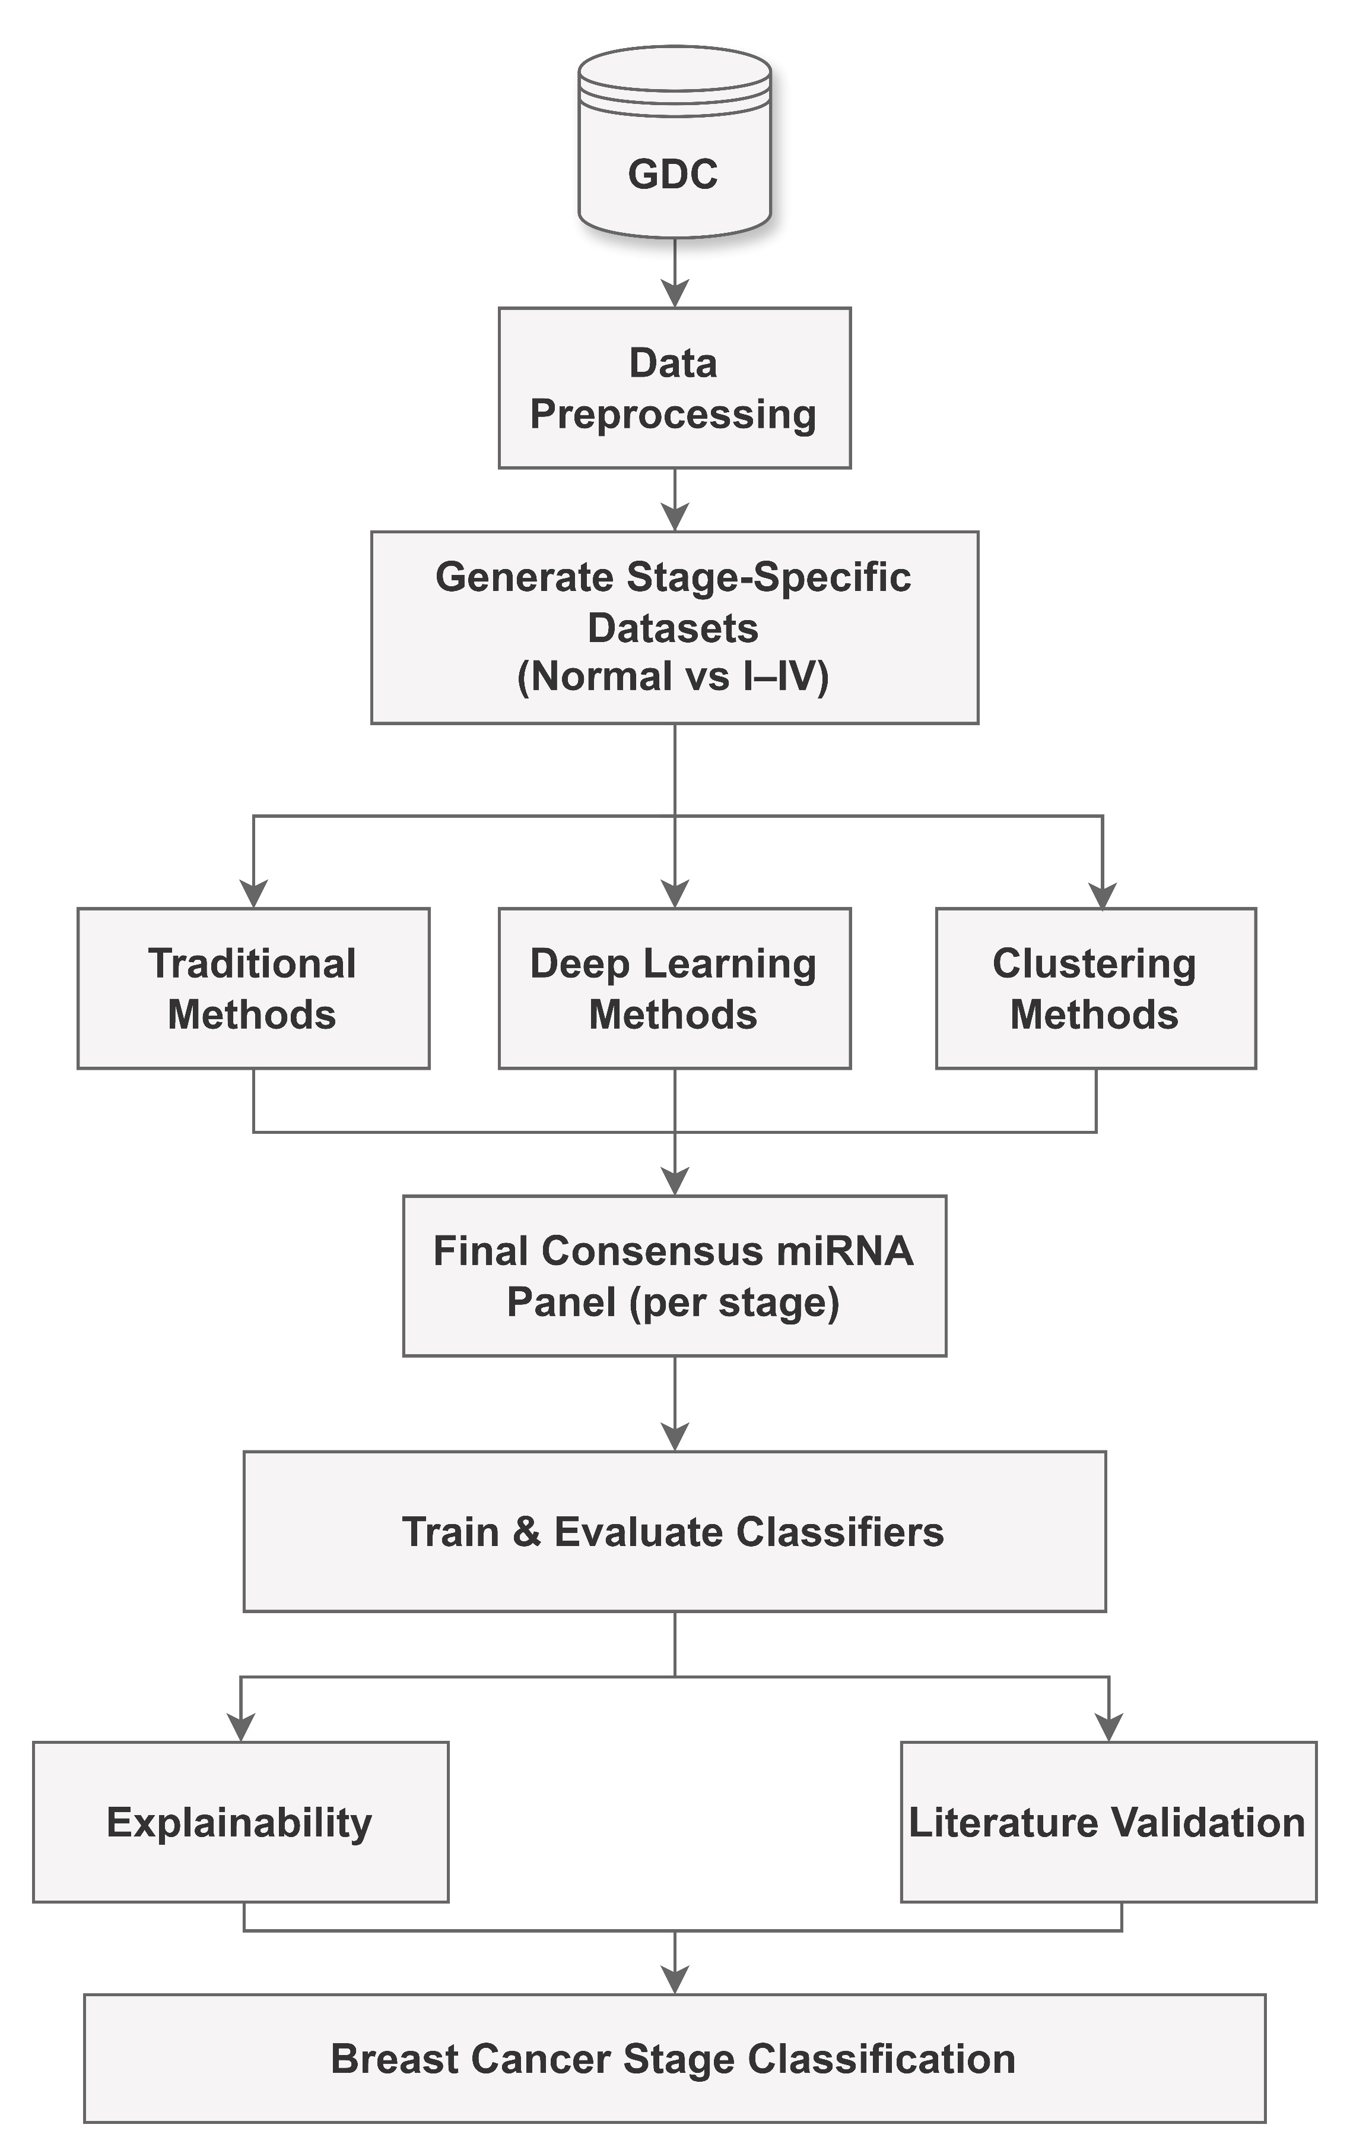
Figure 1: UML activity diagram of the stage-wise breast cancer miRNA classification pipeline.
Figure 1 presents a high-level UML activity diagram for our stage-wise pipeline for breast cancer stage classification with miRNA. The diagram summarizes the main processing blocks, from preprocessing of the GDC inputs and stage-specific dataset generation through feature selection, consensus building, classifier training, and the final explainability and literature validation steps.
The pipeline follows a modular architecture. It starts with miRNA expression files and clinical metadata downloaded from the GDC data portal. These inputs are cleaned, normalized, and merged into a dataset where each row corresponds to one patient and the columns contain miRNA expression values plus an encoded stage label. From this table, the workflow builds four separate binary datasets: Normal vs Stage I, Normal vs Stage II, Normal vs Stage III, and Normal vs Stage IV. Each dataset keeps the full set of miRNA features but rewrites the labels into a simple normal-versus-stage format so that all later steps can be applied consistently for each cancer stage.
For each stage dataset, the diagram shows three branches running in parallel. One branch applies traditional feature selection techniques, another uses deep learning models to derive feature-importance scores, and a third uses clustering to select groups of miRNAs with similar expression patterns. Each branch produces one or more candidate miRNA panels for every stage, giving different views of which features might be informative.
These outputs from the different methods are then brought together in a consensus step. Here, the pipeline counts how often each miRNA appears across methods within a family and forms stage-wise consensus panels based on agreement level. The resulting panels are sent to the classification module, where standard machine learning classifiers are trained and evaluated. Depending on how many samples are available and how imbalanced the data are for each stage, the workflow uses either a stratified train–test split or stratified cross-validation to estimate performance and records metrics such as accuracy, sensitivity, specificity, and AUC.
Finally, the results flow into the explainability and literature validation parts of the diagram. These components highlight the most promising configurations for each stage, summarize how performance changes across stages and feature selection families, and identify miRNAs that appear repeatedly in the consensus panels. Those recurring candidates are then compared with miRNAs reported in the breast cancer literature to help interpret the biological relevance of the findings.

C. Detailed Subsystem Design using UML and Circuit Diagrams with Explanations
Author: Anika Baro Villa

C.1 Data Preprocessing and Stage-Wise Dataset Subsystem
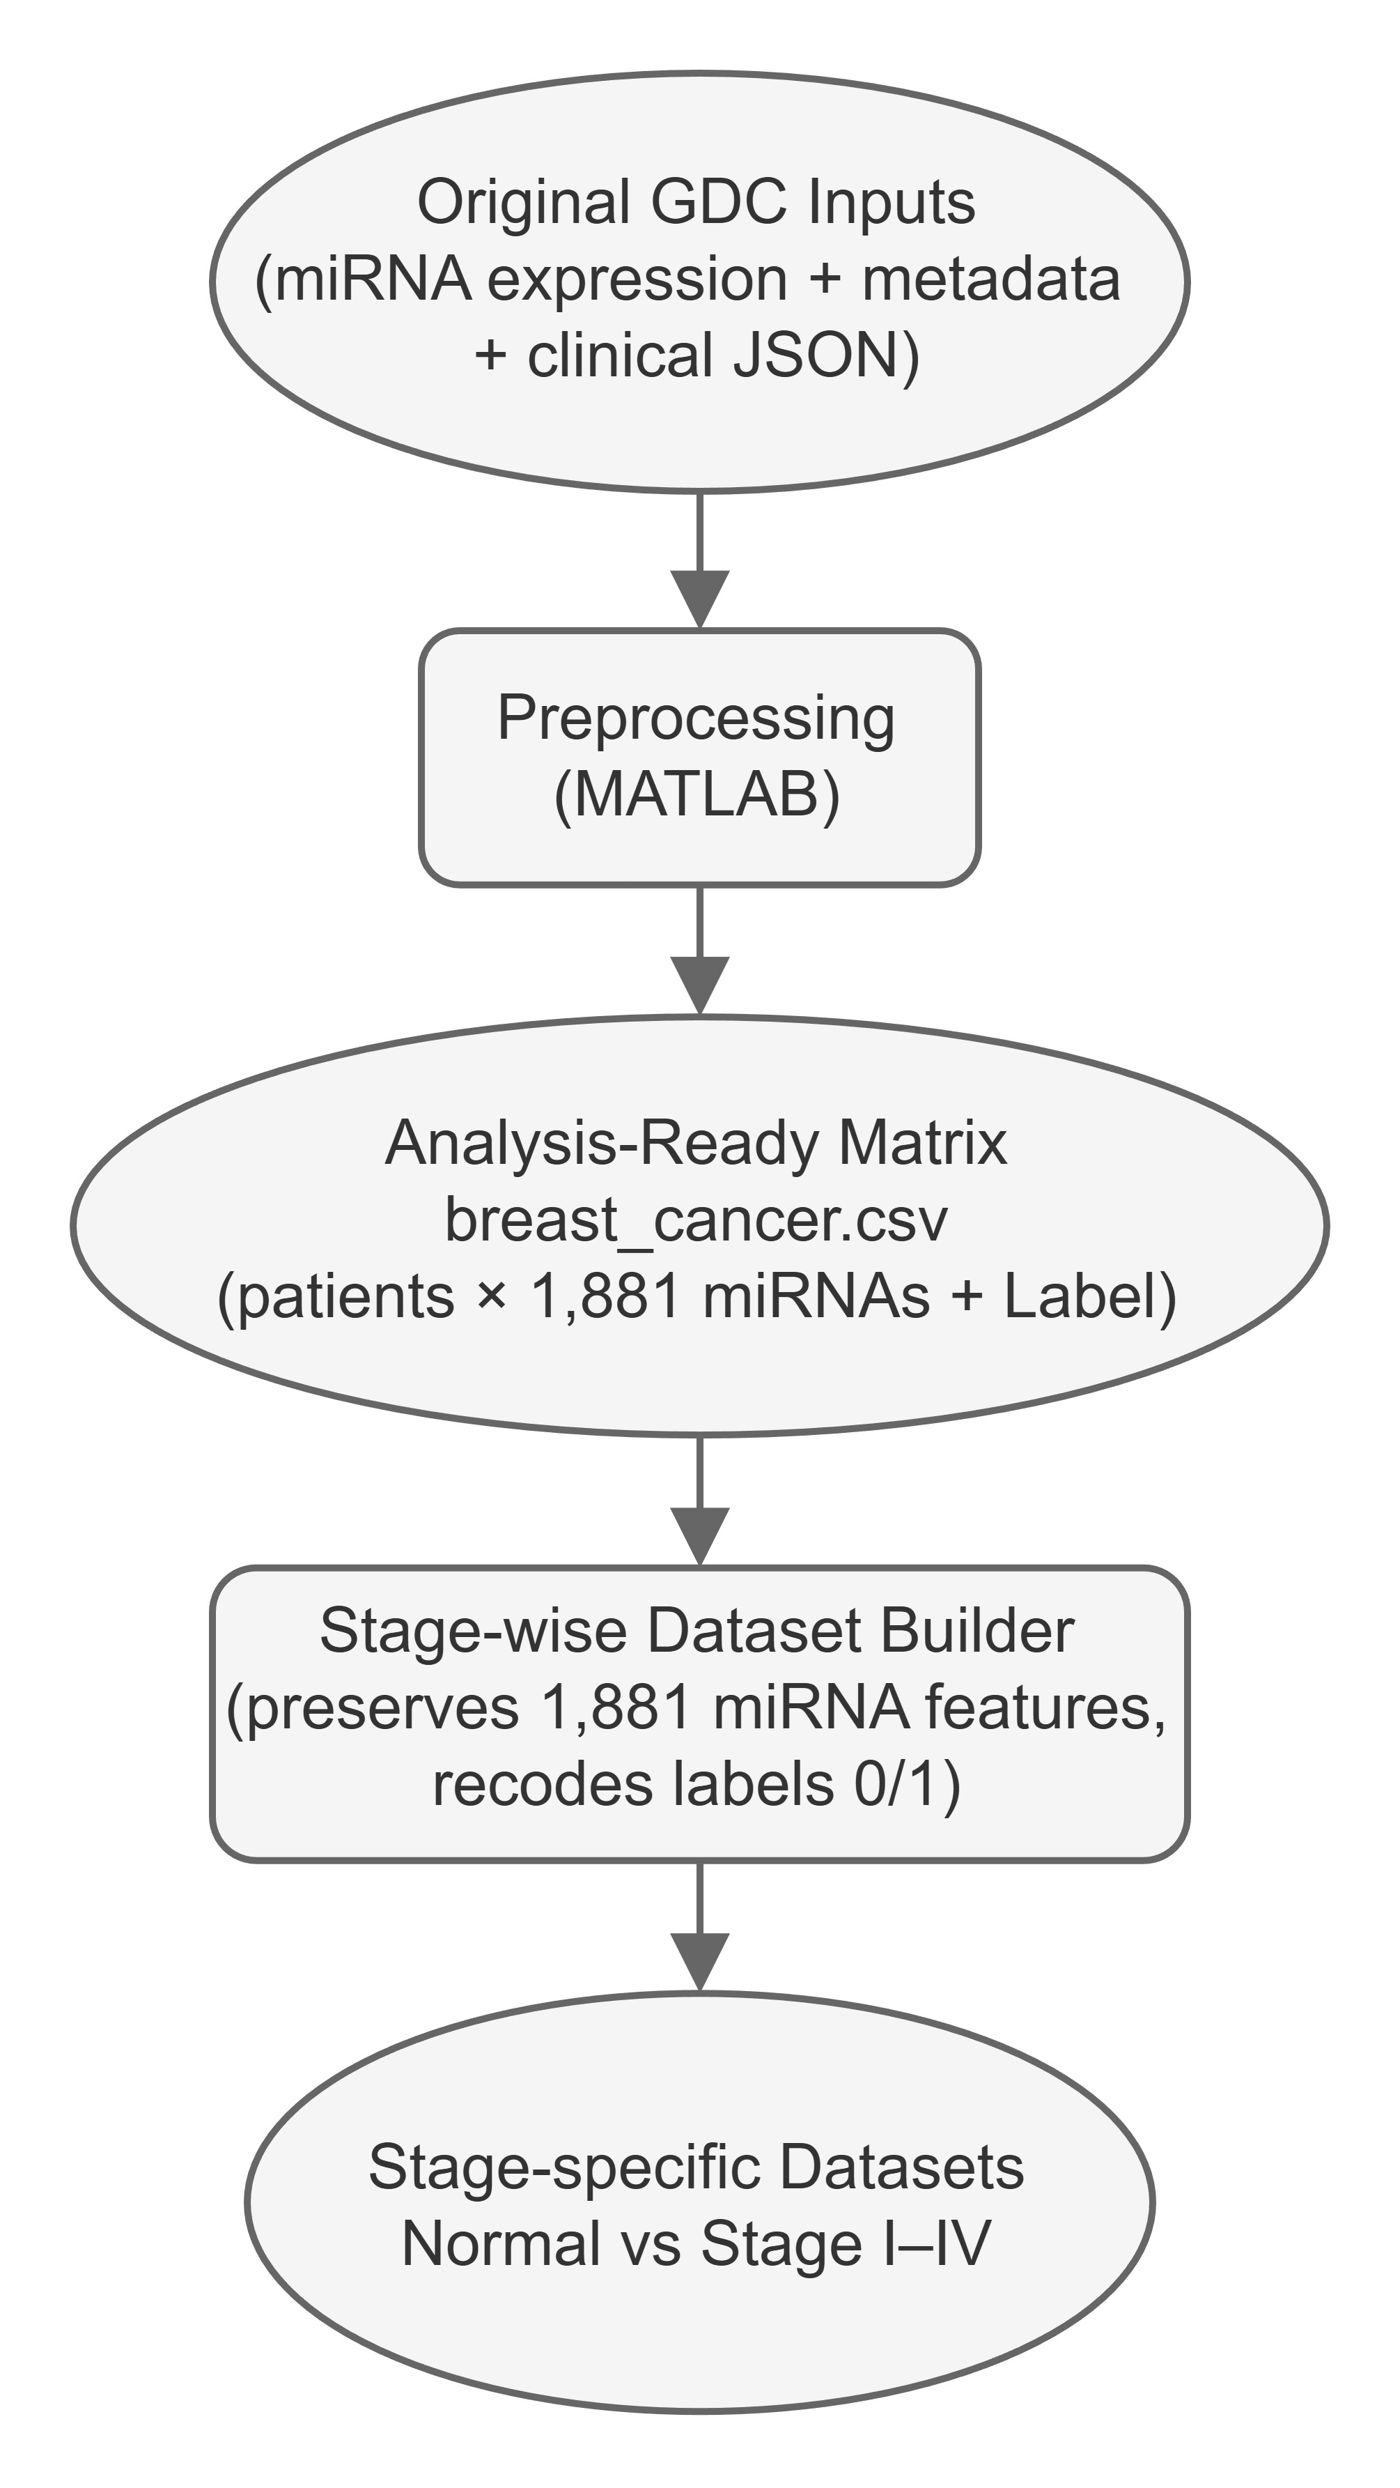
Figure 2: UML activity diagram of the data preprocessing and stage-wise dataset subsystem.
This subsystem is responsible for turning the raw TCGA/GDC miRNA-Seq files and clinical metadata into the separate datasets for each stage that the rest of the pipeline uses. The main steps of this preprocessing and dataset construction workflow are summarized in the UML activity diagram in Figure 2. It starts from the downloaded miRNA expression profiles for tumor and normal tissue, together with the associated metadata and clinical JSON files. MATLAB scripts developed by our sponsor, Dr. Ali Ibrahim, as part of his previous research read each expression file, extract the normalized reads_per_million_miRNA_mapped values, and discard any extra annotation files that do not contain expression data. In parallel, the scripts build a link between file_id, case_id, and the breast cancer stage by combining information from the metadata and clinical JSONs. Text-based stage labels are cleaned, sub-stages are collapsed into four main categories (Stages I through IV), and all stages are encoded numerically in a Label column (int64), where 0 denotes normal tissue and the values 1 through 4 represent breast cancer Stages I through IV.
Using these pieces, the subsystem constructs a single table (breast_cancer.csv) that is ready for analysis. Each row corresponds to one patient sample, and the columns capture normalized expression levels for a wide range of human miRNAs plus the encoded stage label. The final dataset contains 1,209 samples and 1,881 miRNA expression features.
From this dataset, a small Python component of the subsystem then generates four binary datasets: Normal vs Stage I, Normal vs Stage II, Normal vs Stage III, and Normal vs Stage IV. For each target stage, it filters the rows to keep all normal samples and all samples from that stage, and recodes the labels into a simple 0/1 scheme (0 for normal and 1 for the target stage). The output of this subsystem is a consistent set of datasets, one for each stage, that share the same miRNA feature space and are ready to be passed into the feature selection subsystem.

C.2 Stage-wise Feature Selection Subsystem

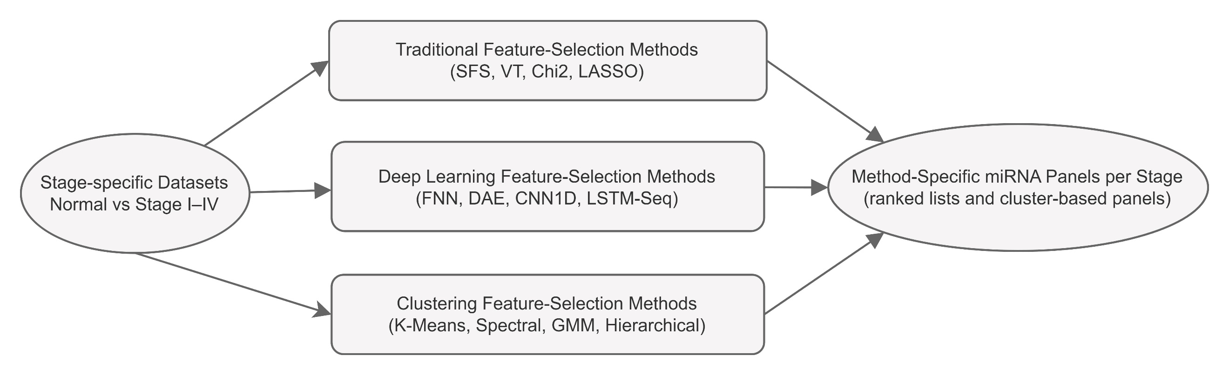
Figure 3: UML activity diagram of the stage-wise feature selection subsystem.
This subsystem takes each of the four stage specific datasets and produces candidate miRNA panels using three families of methods: traditional feature selection, deep learning based selection, and clustering based selection. Each family looks at the data in a different way, so running them side by side gives several views of which miRNAs may help separate normal tissue from a given cancer stage. Later, these views are combined into consensus panels instead of relying on a single method. The main steps of this feature selection workflow are summarized in the UML activity diagram in Figure 3.
For every stage (Normal vs Stage I, II, III, and IV), the subsystem first loads the corresponding dataset and applies common preprocessing steps in Python. Features are stored in NumPy and pandas structures, labels are mapped to 0 and 1, and a stratified train–test split with fixed random seeds is created so that methods inside the same family work on the same training and testing data. For the neural network models, the training set is further divided into training and validation sets. When needed, for example for LASSO or the neural network models, the miRNA features are standardized with StandardScaler, and class weights are computed to partially correct for the imbalance between normal and cancer samples during training.
In the traditional family, the subsystem runs four methods on each stage: Sequential Feature Selection, Variance Threshold, Chi-Square filtering, and LASSO Logistic Regression. Each method produces a ranking of miRNAs based on its own criterion, such as the model coefficients in LASSO. From these rankings, the subsystem exports top k panels (k = 5, 10, and 15) as CSV files with a consistent miRNA column header so that later notebooks can read them without extra formatting.
The deep learning family follows a similar pattern but uses importance scores learned by neural models instead of hand designed criteria. For each stage, the subsystem trains a small set of architectures, including a Feedforward Neural Network, a Denoising Autoencoder, a one dimensional Convolutional Neural Network, and a Long Short-Term Memory model. After training, feature scores are derived from model parameters or gradients, for example by combining the absolute weights that connect to each input feature. The miRNAs are sorted by these scores, and the top 5, top 10, and top 15 lists are exported in the same CSV format as the traditional methods.
The clustering family takes a different approach by grouping miRNAs instead of treating them only as separate columns in a feature matrix. For each stage, the expression matrix is transposed so that each row corresponds to one miRNA across patients. The subsystem removes miRNAs with zero variance, standardizes the remaining profiles, and applies unsupervised algorithms such as K-Means, Spectral Clustering, Gaussian Mixture Model, and Hierarchical Clustering with two clusters. For each clustering method and stage, one of the clusters is chosen based on simple rules that avoid extremely small clusters, and the miRNAs in that cluster form a larger panel. These panels are also saved as CSV files with consistent names.
By the end of this subsystem, the pipeline has produced a diverse collection of candidate miRNA panels for every stage and method family: small ranked lists from the traditional and deep learning methods and larger cluster based panels from the clustering methods. All of these outputs use standardized headers and filenames so that the next subsystem can combine them into consensus miRNA panels for each stage.

C.3 Stage-wise Consensus miRNA Panel Subsystem

This subsystem is responsible for combining the method specific outputs within each family into more stable stage-wise miRNA panels. It takes as input the CSV files produced by the traditional, deep learning, and clustering families and applies a simple counting approach. For a given family and stage (and, when needed, a given k value), it loads all available miRNA lists, standardizes the names, and counts how many methods selected each miRNA. The main steps of this consensus building workflow are summarized in the UML activity diagram in Figure 4.

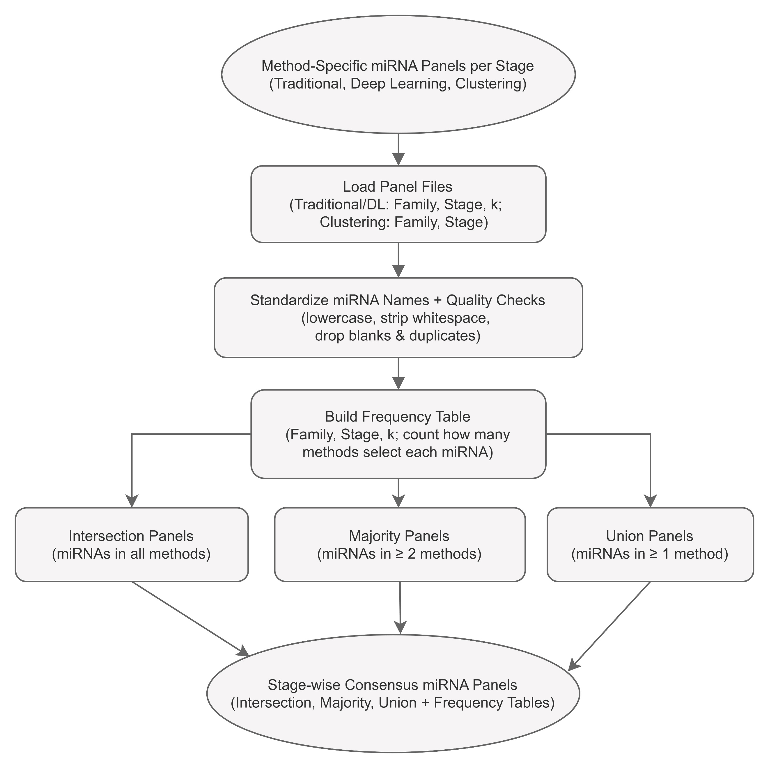
Figure 4: UML activity diagram of the stage-wise consensus miRNA panel subsystem.
Name standardization follows the same rules for every list: convert names to lower case, strip extra spaces, and remove blank or duplicated entries. After this cleaning step, the subsystem builds a frequency table for each family, stage, and k. This table records, for every miRNA that appears in any list, how many methods picked it. Using these counts, the subsystem defines three types of consensus panels: intersection panels contain only miRNAs that appear in all methods for that family and stage; majority panels contain miRNAs that appear in at least two methods; and union panels contain every miRNA that appears in at least one method.
The final output of this subsystem is a set of consensus miRNA panels for Stages I through IV in each method family, together with the corresponding frequency tables. These consensus panels are the feature sets that the classification subsystem uses in the next stage of the pipeline.

C.4 Classification and Evaluation Subsystem
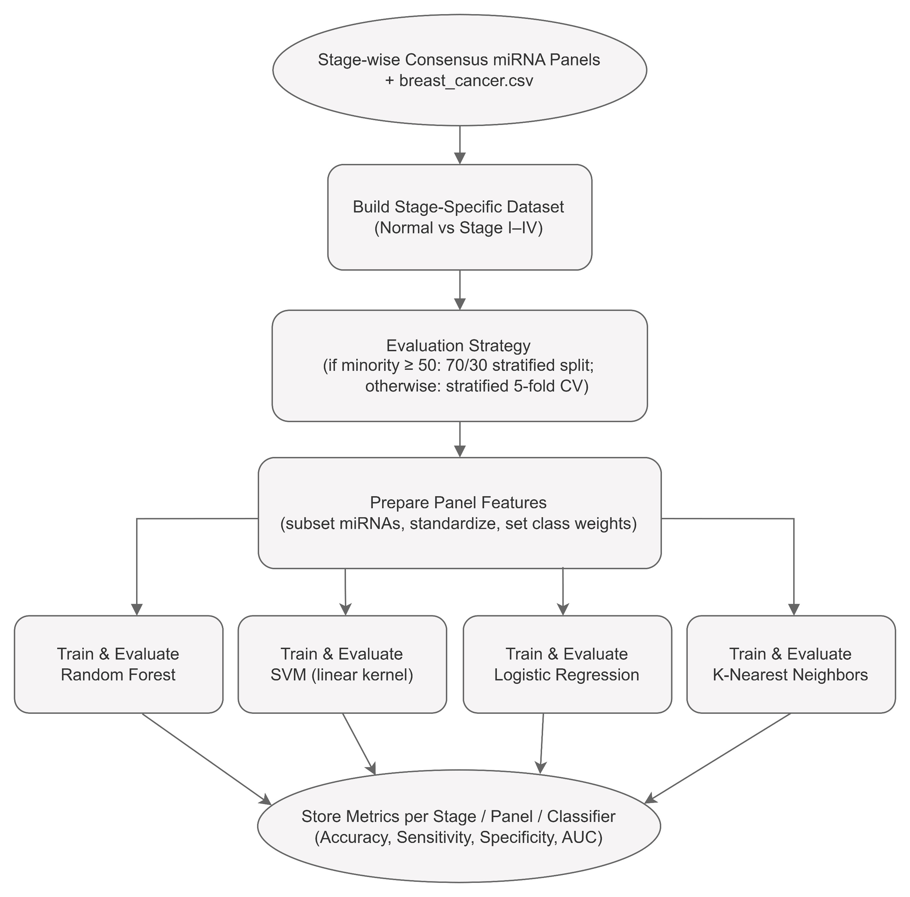
Figure 5: UML activity diagram of the classification and evaluation subsystem.
This subsystem takes the consensus panels together with the original breast_cancer.csv dataset and evaluates how well each panel supports normal versus Stage I–IV classification. For a given stage and consensus panel, it first selects the columns that correspond to the miRNAs in that panel, creating a reduced feature matrix that only includes those miRNAs. The main steps of this classification and evaluation workflow are summarized in the UML activity diagram in Figure 5.
The subsystem then chooses an evaluation strategy based on the class distribution for that stage. For Stages I through III, which have a moderate number of cancer samples, it uses a stratified train–test split (for example, 70% training and 30% testing) so that each class is proportionally represented in both sets. For Stage IV, where only 15 cancer cases are available, it uses stratified 5-fold cross-validation to obtain more robust estimates while still using most of the limited data for training in each fold. The resulting class distributions and selected validation strategies for each stage are summarized in Table 3.

Stage | Normal Samples | Cancer Samples | Total Samples | Validation Strategy
Stage I | 265 | 173 | 438 | 70/30 stratified train–test split
Stage II | 265 | 595 | 860 | 70/30 stratified train–test split
Stage III | 265 | 161 | 426 | 70/30 stratified train–test split
Stage IV | 265 | 15 | 280 | Stratified 5-fold cross-validation
Table 3: Stage-wise binary dataset sizes and validation strategies.
Within each split or fold, the subsystem trains a set of standard classifiers: Random Forest, Support Vector Machine with a linear kernel, Logistic Regression, and K-Nearest Neighbors. Class weights and feature scaling are used when appropriate to handle the imbalance between normal and cancer samples and to make model training more stable. After fitting each model, the subsystem computes four metrics: accuracy, sensitivity, specificity, and area under the ROC curve. It then records these metrics together with the corresponding stage, method family, consensus rule, and classifier. The result is a single table of performance for a large number of configurations, which is later filtered to identify models that are both reasonably accurate and interpretable.

C.5 Explainability and Literature Validation Subsystem

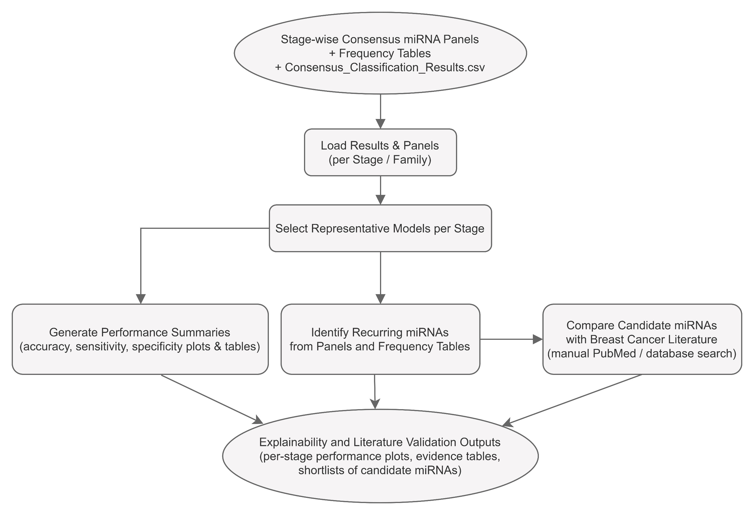
Figure 6: UML activity diagram of the explainability and literature validation subsystem.

This final subsystem focuses on turning the metrics and miRNA panels into outputs that are easier to interpret and compare with existing work. It uses the consolidated results from the classification subsystem together with the consensus panels and their frequency tables. As a first step, it selects a small set of representative configurations for each stage, such as majority consensus panels that reach a reasonable balance between sensitivity and specificity. The main steps of this explainability and literature validation workflow are summarized in the UML activity diagram in Figure 6.

Once those representative models are chosen, the subsystem generates plots and tables that summarize how the pipeline behaves. Examples include bar charts of accuracy by stage, grouped plots of sensitivity and specificity, and tables that list the miRNAs selected in each chosen panel. The subsystem also inspects the frequency tables to find miRNAs that appear often across different methods or stages and marks them as potential biomarker candidates. For a subset of these candidates, we perform a manual search of the breast cancer literature and check whether they have been reported before, so we can see when our results agree with known biology and when they may suggest new hypotheses. The outputs of this subsystem include figures, tables, and short lists of candidate miRNAs that we use to analyze and interpret our results.

D. Comprehensive Testing Results with Discussions
Author: Anika Baro Villa
In our system, testing is built directly into the pipeline. The classification and evaluation subsystem (Section C.4) applies the chosen validation strategy (either a 70/30 stratified split or stratified 5-fold cross-validation) to every consensus panel and records accuracy, sensitivity, specificity, and AUC. This process produces a large table of results that covers many combinations of stage, method family, consensus rule, and classifier, so to keep the discussion manageable we focus on a small set of representative models.
For each stage, we selected one majority consensus panel that gives a reasonable balance between sensitivity and specificity. For Stages I, II, and IV, the selected models come from the traditional feature selection family; for Stage III, the selected model comes from the clustering family. All of them follow the same stage specific validation strategies summarized in Table 3.

Figure 7 shows the test accuracy of these selected models. Stage I reaches about 61.4% accuracy, Stage II about 64.0%, and Stage III about 61.7%. These values stay in a narrow band in the low to mid sixties. This is a moderate level of performance and is reasonable for a difficult task that uses only miRNA expression, with many features and imbalanced classes. Stage IV shows a higher accuracy, around 84.6%, but this number is based on only 15 Stage IV cancer samples, even though cross-validation is used. Because the positive class is so small, the Stage IV accuracy has high uncertainty, so we treat it as exploratory rather than as a firm result.

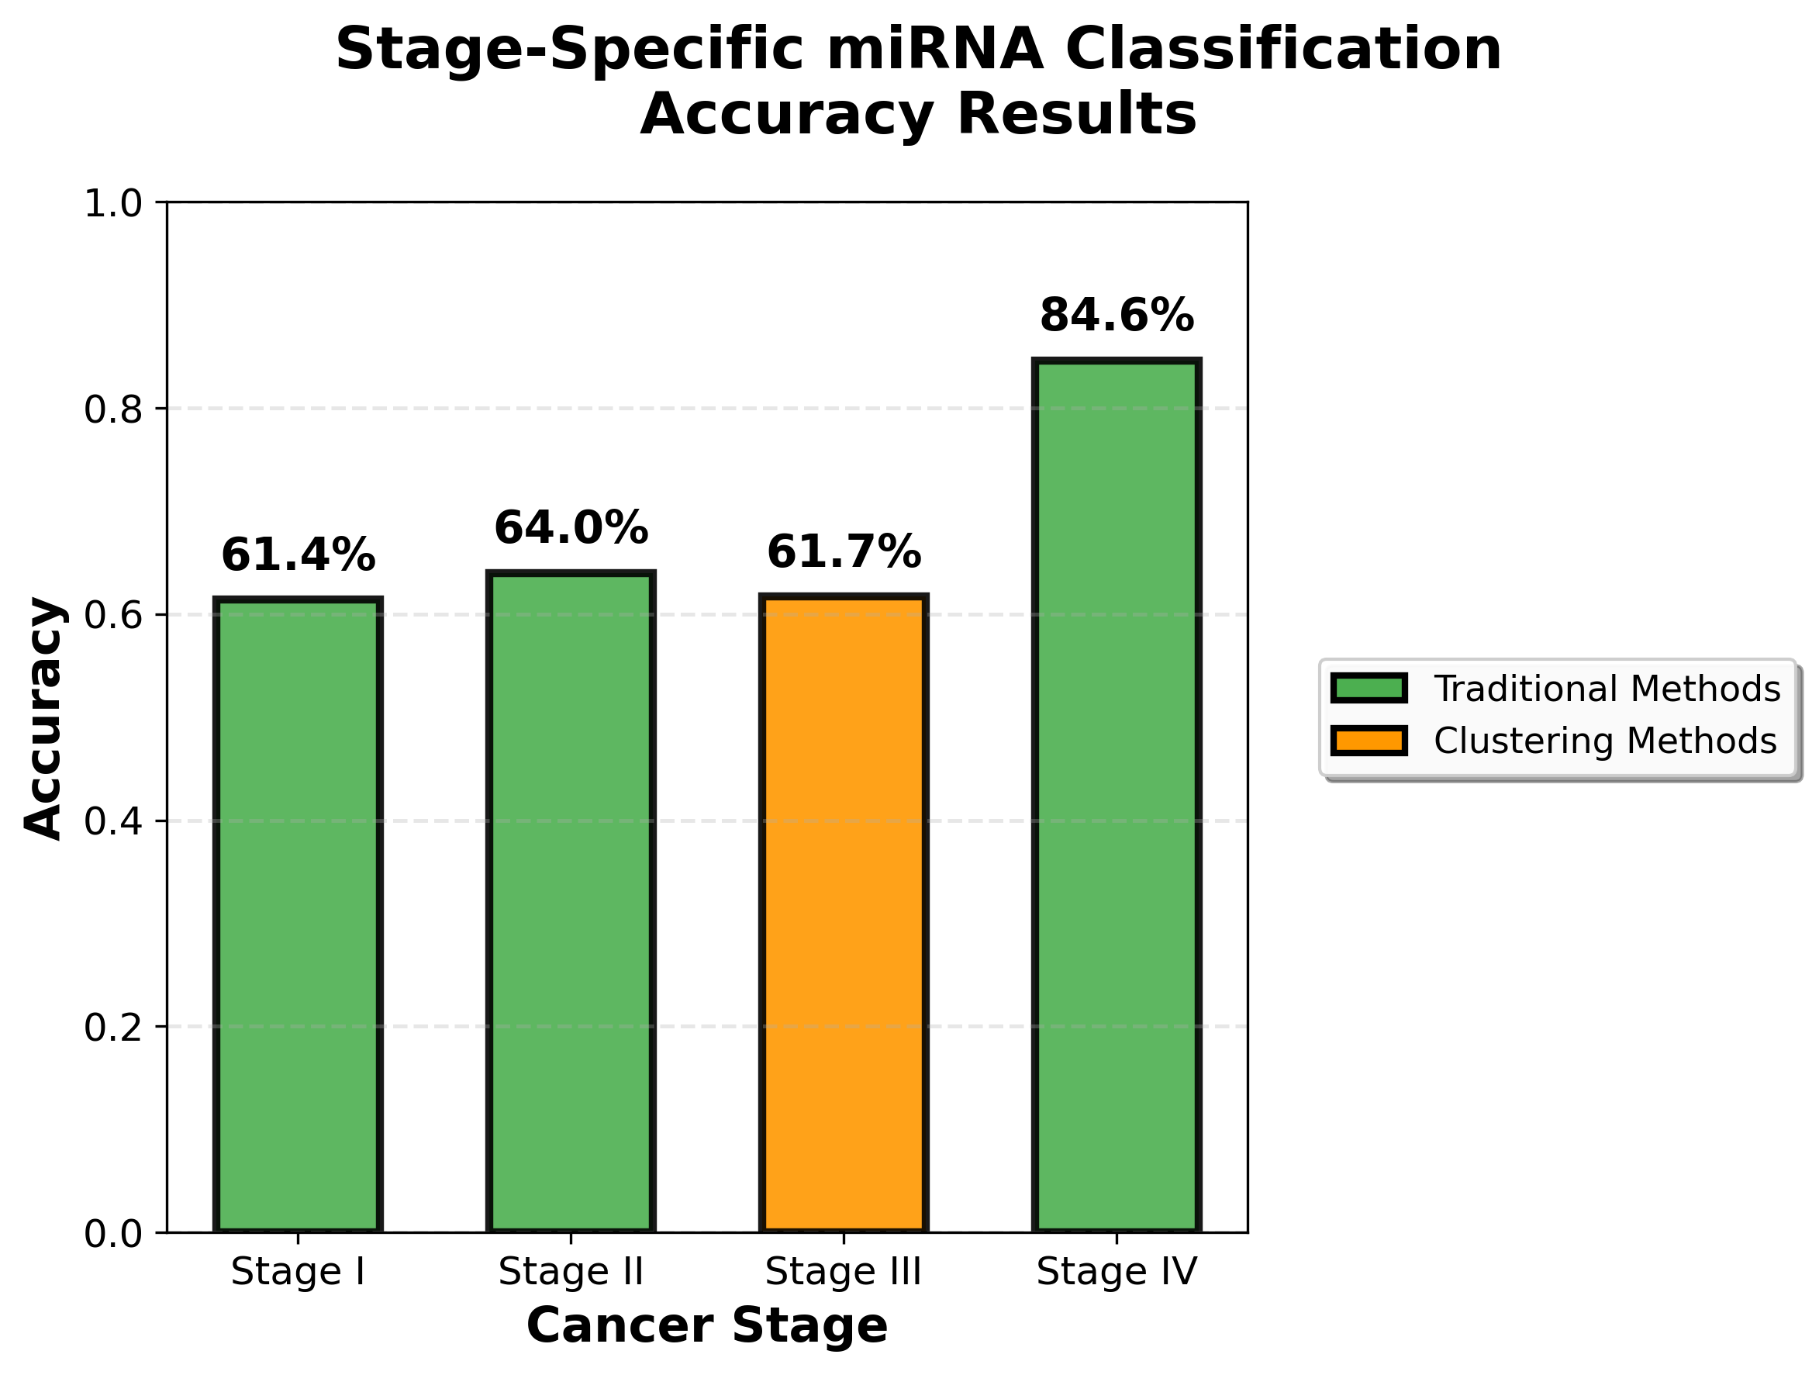
Figure 7: Stage-wise Classification Accuracy

Accuracy by itself can hide important details, so Figure 8 breaks these same models down into their sensitivity and specificity. For Stage I, sensitivity is about 40% and specificity about 75%. This model is conservative: it is better at avoiding false alarms in normal tissue than at catching all Stage I cancers. For Stage II, sensitivity is high, about 86%, but specificity is low, about 15%. The model flags many samples as Stage II cancer, which helps catch most true Stage II cases but also mislabels many normal samples, reflecting the strong imbalance toward Stage II in the dataset.

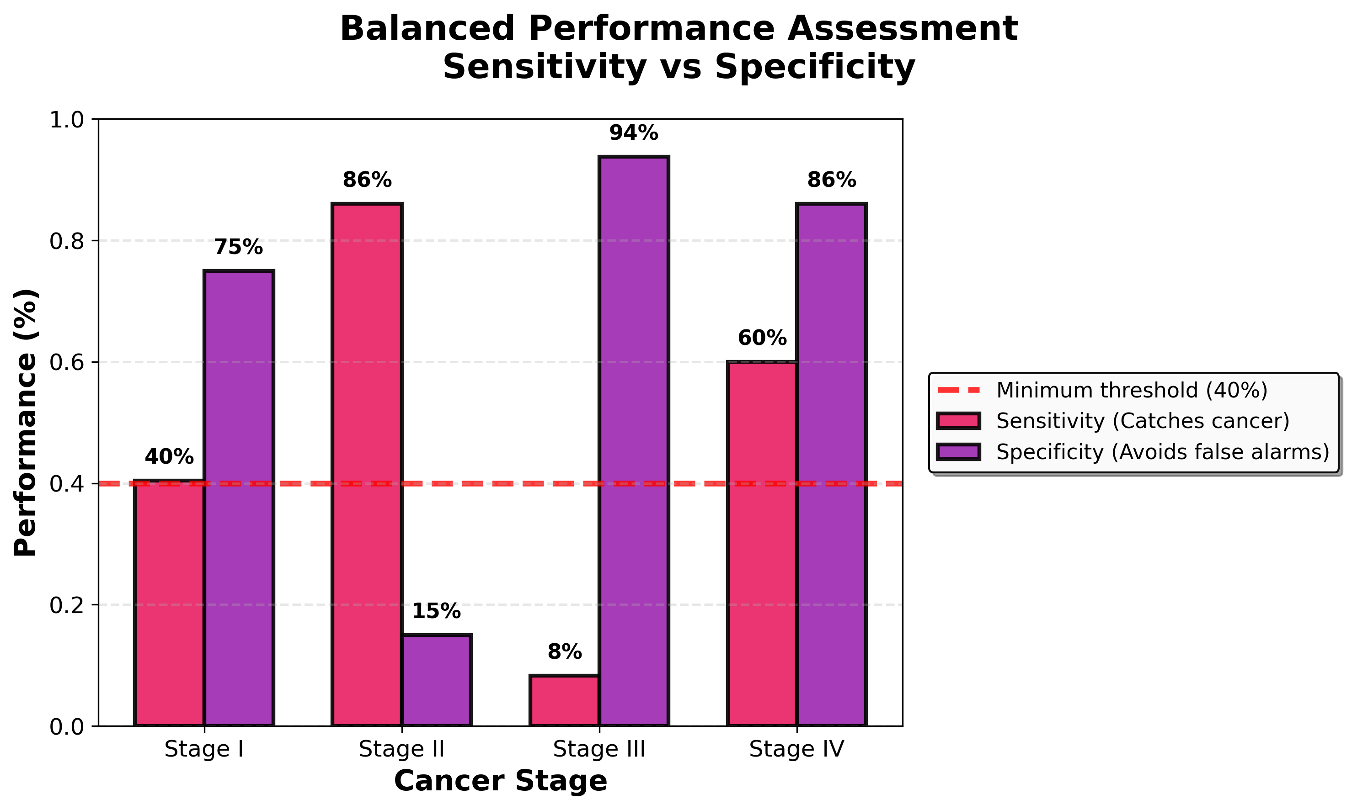
Figure 8: Stage-wise Sensitivity and Specificity
For Stage III, sensitivity is very low (around 8%) and specificity very high (around 94%). The model almost always predicts “normal,” so it rarely raises false alarms but misses most Stage III cancers. This is a clear weakness of our current setup for Stage III. For Stage IV, sensitivity is about 60% and specificity about 86%, which looks more balanced, but again these values come from only 15 cancer samples and should be interpreted with caution. Together, Figures 7 and 8 show why accuracy alone can be misleading, especially for Stage III and Stage IV.
Overall, these results show that our stage specific consensus pipeline can recover useful signal from miRNA expression data and achieve realistic performance for several stages, but they also make clear how strongly the models are affected by class imbalance and limited sample sizes. In particular, the small number of Stage IV cases and the low sensitivity for Stage III limit how much we can rely on those models in practice. These findings point to the need for larger and more balanced datasets, as well as external validation on independent cohorts, before this type of system could be considered for real clinical use.

IV. CONCLUDING REMARKS
Author: Nicholas Campos
This capstone project successfully developed a comprehensive, reproducible pipeline for breast cancer stage classification using miRNA biomarkers. Our systematic comparison of traditional machine learning, deep learning, and clustering approaches demonstrated that multiple methodologies can identify meaningful biomarker candidates when applied rigorously to the same data. The resulting stage-specific consensus panels achieved competitive performance (67.9% average accuracy) while maintaining interpretability and biological plausibility.
Several key achievements stand out. We built a complete end-to-end system that transforms raw TCGA data into validated classification results through five interconnected subsystems. We implemented twelve different feature selection methods across three methodological families, providing comprehensive coverage of available approaches. We adapted our validation strategy to each stage's constraints by using stratified train-test splits for Stages I through III and 5-fold cross-validation for Stage IV's limited 15 samples. Our consensus approach reduced method-specific variability and highlighted miRNAs that appeared consistently across different selection strategies.
The project also revealed important limitations. Stage III demonstrated particularly poor sensitivity (8%), indicating our current feature sets struggle to capture that stage's molecular patterns. Stage IV's 84.6% accuracy must be interpreted cautiously given only 15 cancer cases, despite using cross-validation. The overall moderate accuracy (61-64% for Stages I-III) suggests miRNA expression alone may be insufficient for precise staging, and integrating additional data types could substantially improve performance.
From a technical perspective, several improvements would strengthen the system. The hierarchical clustering implementation initially failed due to inappropriate cluster-size selection, producing only one feature before we switched to variance-based selection. Implementing automated validation checks earlier would have caught this immediately. More sophisticated feature selection methods that jointly optimize feature selection and classification might capture complex interactions our current methods miss. Most critically, external validation on independent datasets would assess whether selected biomarkers generalize beyond TCGA.
The experience taught us that successful machine learning in healthcare requires more than algorithmic sophistication. Methodological rigor, including strict test set isolation, appropriate validation for sample constraints, and honest reporting of limitations, matters as much as model complexity. Systematic comparison across methods proved more informative than achieving the highest accuracy with a single approach. Failures and limitations, when documented transparently, contribute as much to scientific progress as successes.
If given the opportunity to extend this work, collecting additional Stage III and Stage IV samples would dramatically improve model reliability. Implementing explainable AI techniques beyond simple frequency analysis could provide deeper biological insights. Integrating miRNA-based predictions with existing clinical staging through ensemble approaches might produce hybrid models that outperform either approach alone.
In conclusion, this project demonstrates that systematic, multi-method comparison provides a viable path toward identifying robust miRNA biomarkers despite significant data challenges. Our pipeline produces interpretable results suitable for biological follow-up and adapts intelligently to varying sample constraints. While not ready for clinical deployment, it establishes methodological foundations and identifies specific barriers that must be addressed before miRNA-based staging becomes practical. The experience reinforced that rigorous engineering practices, including modularity, reproducibility, appropriate validation, and honest assessment, are just as critical in biomedical machine learning as in traditional software engineering.

V. REFERENCES
[1] M. V. Iorio, M. Ferracin, C.-G. Liu, A. Veronese, R. Spizzo, S. Sabbioni, et al.,
“MicroRNA gene expression deregulation in human breast cancer,” Cancer Research, vol. 65, no. 16, pp. 7065–7070, Aug. 2005.
[2] S. Volinia, G. A. Calin, C.-G. Liu, S. Ambs, A. Cimmino, F. Petrocca, et al.,
“A microRNA expression signature of human solid tumors defines cancer gene targets,” Proceedings of the National Academy of Sciences, vol. 103, no. 7, pp. 2257–2261, Feb. 2006.
[3] R. Tibshirani, “Regression shrinkage and selection via the LASSO,” Journal of the Royal Statistical Society: Series B, vol. 58, no. 1, pp. 267–288, 1996.
[4] F. M. Alakwaa, K. Chaudhary, and L. X. Garmire, “Deep learning accurately predicts estrogen receptor status in breast cancer metabolomics data,” Journal of Proteome Research, vol. 17, no. 1, pp. 337–347, Jan. 2018.
[5] S. Min, B. Lee, and S. Yoon, “Deep learning in bioinformatics,” Briefings in Bioinformatics, vol. 18, no. 5, pp. 851–869, Sep. 2017.
[6] Q. Jiang, Y. Wang, Y. Hao, L. Juan, M. Teng, X. Zhang, and Y. Liu, “miR2Disease: A manually curated database for microRNA deregulation in human disease,” Nucleic Acids Research, vol. 37, no. suppl_1, pp. D98–D104, Jan. 2009.
[7] The Cancer Genome Atlas Research Network, "Comprehensive molecular portraits of human breast tumours," Nature, vol. 490, no. 7418, pp. 61-70, Oct. 2012.
[8] National Cancer Institute, "Genomic Data Commons Data Portal," NIH, 2023. [Online]. Available: https://portal.gdc.cancer.gov/

